 | Application  note
RS8000 Rock TEST Hammer | Stonex India Pvt Ltd

Application requirement:  Stonex India Pvt Ltd required a non-destructive, accurate and easy to use hardness tester for evaluating marble and granite stone without affecting surface quality. | Solution:  The RS8000 - ISRM a Rebound value is utilised based on International Society of Rock Mechanics (ISRM) Standards for in-situ testing for measuring rebound value, which correlates to surface hardness (and variation across various batches), correlations to unconfined compressive strength (UCS) and rock classification types for identifying inconsistency in material quality, without core sampling.  Achieve faster, more consistent hardness measurements, improving product sorting, reducing complaints and reinforcing their reputation for premium quality.

Customer Name: - Stonex India Pvt Ltd

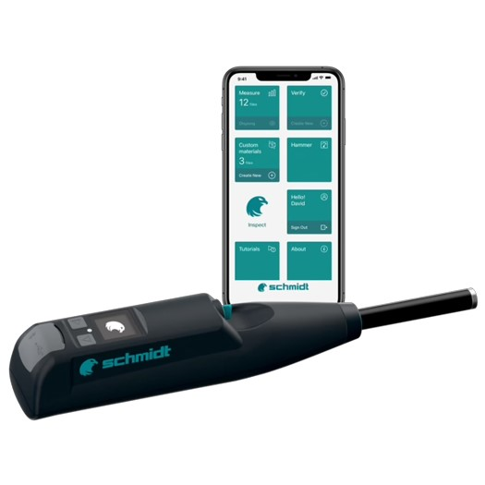

Application requirement:  To maintain their high standards for domestic and international clients, Stonex needed a device capable of testing a wide range of stone types—from softer marbles to denser granite—without damaging the surface or compromising aesthetic quality. The requirement was for a non-destructive, highly accurate, and easy-to-use hardness tester that could function effectively both in the factory and at the quarry site. | Solution:  The RS8000 offered critical features that aligned with Stonex’s operational needs. Its impact angle independence ensured accurate rebound values regardless of test direction—ideal for uneven or angled stone surfaces. Built for field durability, the device is dust- and dirt-resistant, lightweight, and ergonomically designed for extended use in both quarry and factory environments.  The intuitive touchscreen digital display interface, combined with USB/Bluetooth connectivity and a dedicated mobile application, enabled real-time data syncing, easy remote operation, and on-the-go access to test reports and analytics. This significantly simplified quality tracking across multiple sites.  When used for natural stone or rock testing, the RS8000 may report hardness classifications per ISRM standards (International Society for Rock Mechanics), often in rebound numbers that correlate to rock hardness categories.  The RS8000 Rock Schmidt hammer is operated and utilised, generally in both of its versions which provide different levels of Impact energy:  - N: 2.207 Nm  - L: 0.735 Nm  The RS8000 also provides weathering grade determination.  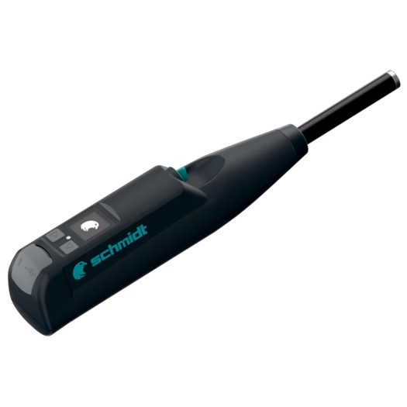  The RS8000 is equipped with preset statistical methods as per ISRM and ASTM standards, allowing automatic calculation of rebound values. It supports critical functions such as Unconfined Compressive Strength (UCS) testing, weathering grade evaluation, and Young’s Modulus estimation through correlation formulas—all essential for geological assessment and high-precision hardness evaluation in natural stone.  By integrating the RS8000, Stonex achieved faster, consistent, and non-destructive hardness testing on both soft marble and hard granite, leading to improved product sorting, fewer customer complaints, and higher overall reliability. The mobile app further empowered their quality team by providing instant access to results, remote device control, and seamless report generation, strengthening both internal audits and client communication.  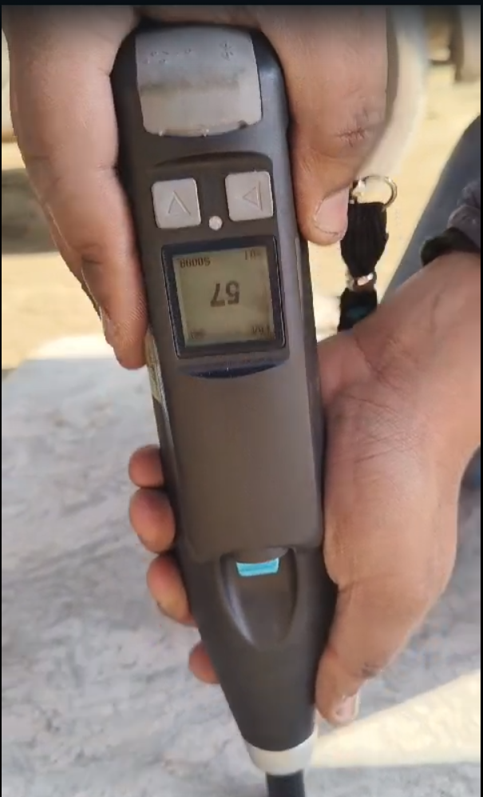  In conclusion, the RS8000 has become an indispensable tool in Stonex’s quality assurance program—offering technical precision, mobile-enabled efficiency, and long-term value for stone testing operations. Its deployment reinforces Stonex’s position as a trusted global supplier of high-quality natural stone.

Document ref: RS8000/stonex | Date: 25 July 2025


